**2020-2021**

**Q1**

**1a.** Answer from tutorials.

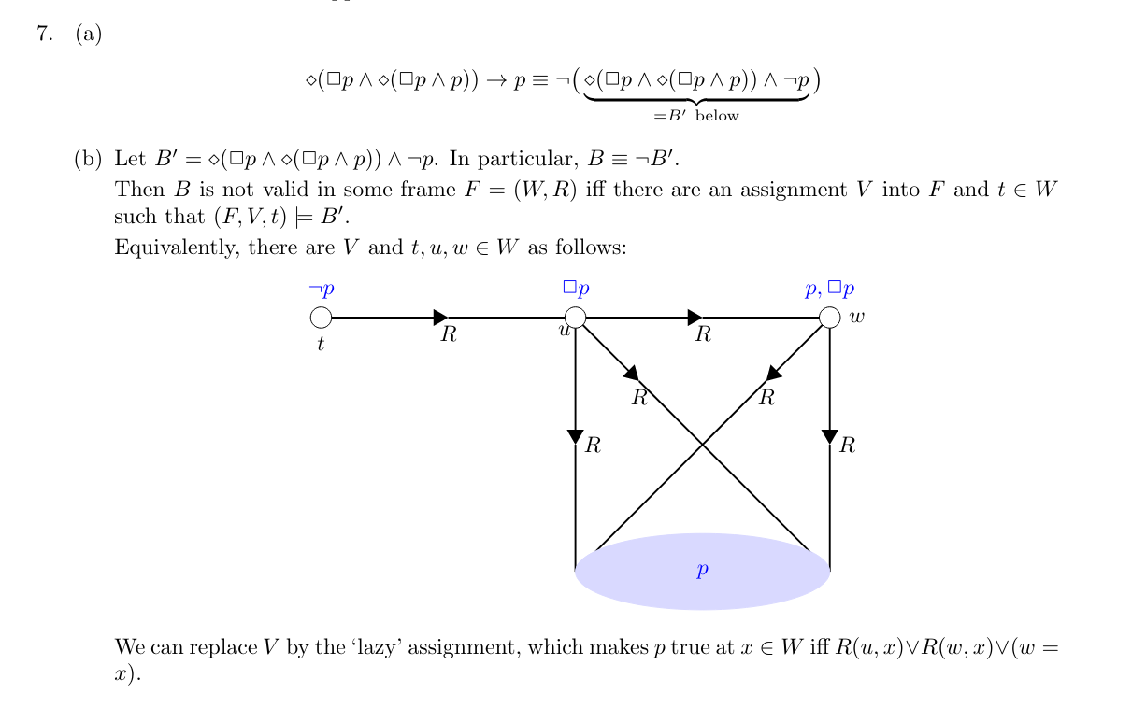

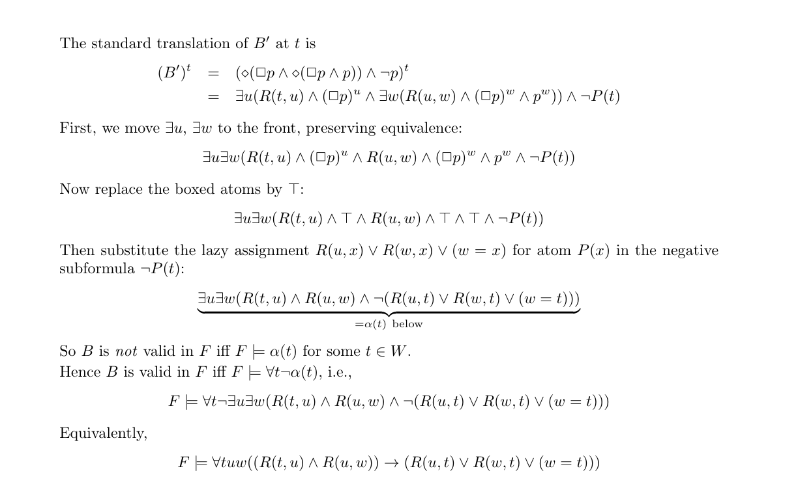

**1bi.** True

**1bii.** False

**1biii.** Assume there is an equivalent LTL formula *A.* Then *A* is true in M.Note that Paths(M’) are a subset of Paths(M), so *A* is also true in M’. But then *EFAGa* is true in M’, which is a contradiction.

**Q2**

**2aii.** Onlyq0 |= Phi3 and q0 |= Phi_4 hold.

**2bii.** Only q0 |= Phi3 holds.

**2ci.** True

**2cii.** False

**2ciii.** EGEFa holds in M while GFa does not, hence they cannot be equivalent. Furthermore, we know from lectures that EGEFa has an LTL equivalent if and only if it is equivalent to itself with path quantifiers removed (ie. It is equivalent to GFa). Since this is not the case, EGEFa has no LTL equivalent.

**Q3**

**3a.** EG(p and q) -> EGp and EGq, but not the other way around: consider a model with x -> y, x -> z, y -> y and z -> z. V(p) = {x, y}, V(q) = {x, z}.

**3bii.** True

**3biii.** True

**3ci.** FcaP is shorthand for trueUcaP, so want to execute mcheck({1}, M, true, caP), which gives the iterations:

Q1 = {} -- initialising variables

Q2 = {9,10,11,12}

Q1 = {9,10,11,12} -- first iteration

Q2 = {7,8,9,10,11,12}

Q1 = {7,8,9,10,11,12}

Q2 = {6,7,8,9,10,11,12}

Q1 = {6,7,8,9,10,11,12}

Q2 = {6,7,8,9,10,11,12}

Final set is {6, 7, 8, 9, 10, 11, 12}

**3cii.** want to execute mcheck({2}, M, true, ¬caP), which gives the iterations:

Q1 = {1,2,3,4,5,6,7,8,9,10,11,12} -- initialising variables

Q2 = {1,2,3,4,5,6,7,8}

Q2 = {1,2,3,4,5,6,7,8,9,10,11,12} -- first iteration

Q1 = {1,2,3,4,5,6,7,8}

Q2 = {1,2,3,4,5,6,7,8}

Q1 = {1,2,3,4,5,6}

Q2 = {1,2,3,4,5,6}

Q1 = {1,2,3,4,5}

Q2 = {1,2,3,4,5}

Q1 = {1,2,3,4,5}

Final set is {1, 2, 3, 4, 5}